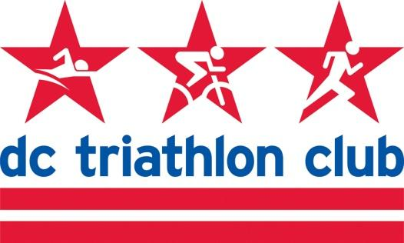

**OCTOBER 2022 BOARD MEETING MINUTES**

Date: Monday, October 17, 2022

Location: Zoom

*In Attendance:* Cindy, Kyle, Liz, Pat, Kelly, Rob, Pat, Mallory, David, Cynthia, Juene

*Absent:* N/A

**Meeting Minutes**

* Approved September’s meeting minutes

**Financials (Pat)**

* Pat reviewed financials
* September had some expenses but we are doing pretty well from a top line perspective.
* October has some expenses as well with respect to insurance (D&O and club member) coming due.
* We had duathlon revenue come in and gear revenue.
* Nothing out of the ordinary
* Discussion of insurance premiums and Kyle and Pat is on top of it

**Annual Meeting**

* December 10
* Cynthia presented the options - to keep the venue we’ve had in the past (Arlington Cinema & Drafthouse) or move to Board Room (no A/V or in-house food) or Alamo Drafthouse.
* Board room ruled out due to no A/V or food - would need more volunteer support
* Alamo Drafthouse has metro accessibility, but more costs associated with it. It would need to be at 11am for the lesser rental/F&B minimum costs.
* Discussion of Arlington vs. Alamo Drafthouse
* Need to ask about setup time at Alamo.
* Informal poll on which way board members are leaning
* Decision to stay with Arlington and check their availability

**Happy Hours**

* At church hall in Georgetown
* Mallory will coordinate November 17

**2023 Board/Transitions**

* Newsletter blurb to solicit board members
* Voting will take place prior to Thanksgiving
* Voting for awards at the same time
* This will line us up for the Annual Meeting
* President and Secretary are open on Executive Board and needs to be people already on the Board.
  + Mallory is nominated, and willing to do it
  + David willing to be Secretary
* Justin will help with web as a non-board member

**Contact Renewals (NTP, etc)**

* Coach and program manager contracts

**Other Business**

* November meeting: Kyle has a flight and needs to hop off at 8pm. Could move the meeting a week earlier or shorten the meeting.
* Gear Update
  + Flannel pants will be ordered, need 24
  + Kelly has concerns about the fit, will work with Mallory