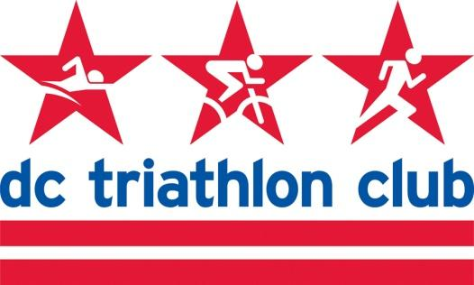

**MAY 2021 BOARD MEETING MINUTES**

Date: Monday, May 10, 2021

Location: In person!!! In a park in Georgetown.

*In Attendance: Kyle, Liz, Mallory, David, Cindy, Pat, Justin, Kelly, Rob, Cynthia*

*Absent: Stephan*

**Approval of April Meeting Minutes**

* Comments to Liz on minutes to be sent by tomorrow COB
* Motion to approve minutes – Justin
* Second – Kelly
* Passed pending any comments via email

**Events – Summer/Fall 2021**

* Masters Swim
  + James Chu sent an email re: pool reopening, the shortage of coaches, and needing a program lead. He would assist with transfer of knowledge.
  + Put a call out to former coaches and also in the newsletter.
  + Discussion of payment structure for program lead for Masters and how compensation would work since participants pay via punch cards.
  + Members may be waiting for Masters to rejoin the Club. It is one of our signature programs.
  + Keep an eye on lane reservations and contact the pools.
* Other Events
  + In person happy hour
  + No specific board member in charge of happy hours right now. Have each person be in charge of a month.
  + Third Thursday of the month
  + Rob will take June
  + Requests to do things in Arlington so we will rotate DC & Arlington to start, a Maryland HH as well (coordinate with MoCo group)
* Programs – NTP and Olympic programs kickoff in the fall
* Hains Point run
  + Successful, people were excited to see others in person again and run together.
  + Very social atmosphere.

o Ambassadors were on board to doing more of this.

o Could probably do this weekly.

o Meet and combine with a bagel stop after.

* Camping weekend

o Late July

o Deep Creek Lake or another location

o Try to find date and location by next board meeting

**Gear Sales**

* Closed gear store 2 weeks ago
* Did well – about 30-40 people ordered gear, total of around 50+ pieces
* Beat the minimums for almost everything
* Cutaway was able to move people from pieces that didn’t meet the money and move them to other pieces.
* Current target in-hands date is mid-late June
* Ordering new water bottles for member kits
* Another round of gear ordering – casual wear would be great. Perhaps open it up for the holidays.
* Online gear sales are going well too
* Gear + Programs – give away with program registration a transition bag or another premium such as a sweat towel or transition towel.

**Retention/Recruitment Update**

* About 10 new members in the last couple of weeks
* Big push with all the community groups and bought ad space on FB. The boosted post gave us 3 conversions so the ads paid for itself.
* Rob has gotten membership inquiries.
* Email draft for people who have fallen out of membership.
* Discount for 10% off is “2021”.

**Gear Swap Idea**

* Facebook group

**Website**

* Discounts are not all up to date – check in with Partnerships

**Ambassador Program Update**

* All ambassadors are on board