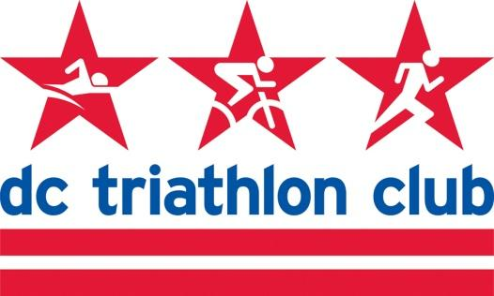

**MARCH 2022 BOARD MEETING MINUTES**

Date: Monday, March 14, 2022

Location: Virtual

*In Attendance: Kyle, Liz, Pat, Kelly, Rob, Pat, Mallory, Juene, David, Cynthia (virtual)*

*Absent: Cindy*

**Review of February Meeting Minutes**

* Board will review when back at a computer and approve via email

**Financial & Budget (Pat)**

* We are in a good place as expected per previous updates.
* Expensive month this month and next, but as expected (Elite Team charges, etc.). We have had membership income the past few months and this is the time when the expenses come to offset that income.
* Nothing major. Gear income will come through. Everyone will buy direct online.
* Membership + gear-related expenses for membership needs discussion.
* We had NTP income for program registration
* Income & Expenses - bulk of income for Jan/Feb is training programs, membership, gear income. Interest income begins to make a small dent. Expenses are fixed such as storage, eating up a lot of our budget but we are making progress on that front.
* Cross-checked against the 2021 budget and we did well. Some things were predicted to be better for income such as Off-Season Spin. We expected December 2021 would be very high and it came in lower.
* We had budgeted money for Masters Swim that was not used due to the program being on hiatus.
* Elite Team budget - a few additional expenses that weren’t expected.
* Budget needs to be approved this month.
* Discussion of budget details, questions and answers on unfinished budget items.
* There are items we haven’t done in a couple of years such as club races, support tent at races, board meetings in person, etc.
* Patrick will send budget out. Updates should be highlighted so he can combine everything. Deadline for changes is **Friday, March 18**. Clean version will be send. Vote by end of next week is the goal.

**Programs Update**

* Registration summary:
  + 4 Ironman registration
  + 17 Half Ironman Registration
  + 7 ODP registrations
  + 124 NTP registrations (new members from this program)
* NTP: First clinic was successful
* Masters Swim - Cindy is continuing to try to re-launch this program.
* Off Season Spin - 2 more weeks. FTP test recording to be repeated for a group for those who are doing Rock n Roll DC half marathon.

**Training**

* Peasantman weekend canceled for lack of registration.
* Contingent in NTP who like to come out for this.
* OWS clinic - geared toward newbies - this should happen.
* Bricnic - reserved for April 23 and publicity starting
* Leads lined up for the first camping weekend
* Deep Creek Lake camping - issues with construction wreaking havoc on the bike ride. Kelly would still like to keep it on the calendar and doing a training camp with adapted ride.

**Other Events (Social, Retreat)**

* Retreat - no date worked for all
  + Make a decision earlier for next year, not wait until after the new year to plan this date
* Cherry Blossom in a couple of weeks - water station. David checking volunteer status.
* No March/April HH scheduled so far.
  + March HH should be next Thursday, March 24
  + Encourage Community Groups to
* Nationals game as a group
  + Kyle reached out - they can set up a site so people can buy tickets individually as part of our group.
  + That should be the HH that month - meet at Bull Pen first.
  + They can add a concession credit onto the cost of the ticket - we should not add this on.
  + Tentatively looking at a Tuesday or Wednesday in the summer
* Ambassadors
  + Question on whether we are continuing. Board doesn’t have the bandwidth to pick new people or to continue the program in a meaningful way.
* Focus on other activities and new member recruitment
* Weekly bike rides on website - people aren’t posting that they are going. Might pick up after OSP ends.

**Tech**

* Justin Bauer can support us with Tech but can’t attend board meetings.
* Position will be vacant on board, since Jorge moved away.
* Kyle is handy with some things on the site that don’t need to go to Justin
* Membership registration and renewal issues
  + Address isn’t checked when renewed so Cutaway is having returned mail.
* Have Justin come to one meeting or separate meeting to discuss

Board mini-retreat on April 21 in evening