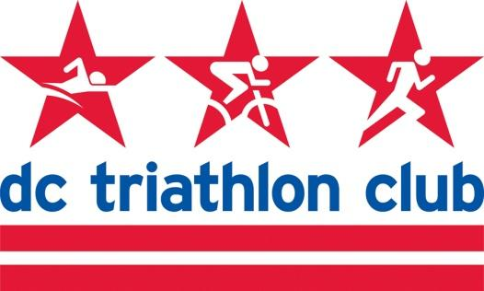

**JUNE 2022 BOARD MEETING MINUTES**

Date: Monday, June 13, 2022

Location: Virtual

*In Attendance:* Cindy, Kyle, Liz, Pat, Kelly, Rob, Pat, Mallory, David, Cynthia

*Absent:* N/A

**Financials (Pat)**

* Cutaway charges will need to go out and are reflected in the balances
* Tracked this in the budget
* Gear sales in April, revenue from this is included
* Revenue for Bricnic and NTP Swim
* Membership revenue was a little down, maybe due to how programs were aligning
* No changes for training/membership/gear
* Expense side – nothing unexpected
* Small gear revenue
* Screw up with Capital One with overcharge

**Training, Elk Creek Review**

* Camp was great
* Last minute cancellations due to Covid and life
* Fun group – good attitude
* Survey is going out
* Soliciting volunteers for future opportunities

**Programs, Eagleman Review**

* Coolest (temperature) Eagleman on record, steady rain/light rain until 1:00pm
* All 70.3 participants finished the race
* Stephan (coach of program) came out and saw participants and supported
* Andy Potts – very engaging and great reminders on the swim
  + Video tape of this might be of interest
* Juene brought tent and set everything up then tested positive, departed
* Happy we had the two tents – should have at least one tent at this
* Met new members
* Accident on Bay Bridge so people stayed

**Open Discussion**

* Club storage (Pat)
  + $301/month
* Pat found something not too far away for less money
* We will save about $150/month
* Need to meet and move storage