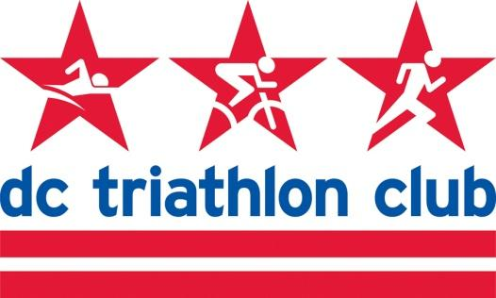

**JUNE 2021 BOARD MEETING MINUTES**

Date: Monday, June 14, 2021

Location: Wundergarten DC

*In Attendance: Kyle, Liz, Mallory, David, Cindy, Justin, Kelly, Rob, Stephan, Cynthia*

*Absent: Pat*

**Review of May Meeting Minutes**

* N/A - pending review

**Financials Review (Pat)**

* Via email

**Programs**

* NTP
  + Lost NTP program lead - resigned due to job conflicts
  + Kyoko is interested in the lead position and this is being solidified
  + Discussion of coordinating the programs with partnerships
* Adaptive NTP
  + Someone reached out about adaptive NTP
  + We are interested in pursuing this and having an adaptive program
* Masters Swim
  + One of the coaches, Sam Rosenthal, stepped up to lead the program
  + James will hand over the workouts and information, and continue coaching 1 workout/week
  + Paying the program lead
    - Monthly fee would be easier than percentage of participants since it is so variable. Look at historical data to determine the amount.
    - Per quarter analyze the income from Masters and pay the lead
  + Pools haven’t opened back up yet - the website says October so we will aim for the fall and await updates.
  + Social media and newsletter communications when we are re-opening Masters swim (when pools open). Introduce them to the new program lead.
  + Idea - Add an option for a package of free Masters Swim class(es) as a membership incentive (instead of membership kit of t-shirt or water bottle). There is already a one free Masters. This might be hard to track. Keep it simple for the volunteers.
  + Masters Swim is being asked about by members quite a bit - we are hopeful to re-open this fall.

**Training Camp**

* July 30-August 1 - Deep Creek Lake
* How many sites to reserve?
* Keep it smaller capacity because it’s non-refundable.
* 5 campsites will be reserved - CS & Kelly Lefler will coordinate about campsite reservation
* Website will be updated, it will go in the newsletter

**Website**

* Rob - Membership inquiries have come through about how to join. It is obvious on a desktop but might need to be more mobile friendly with a JOIN button at the top
* Need a more mobile-friendly button for JOIN on the site, and more prominent on the desktop version. “Join” is at the top but we could change it.
* Could we pare down some of our content as well that isn’t being used/accessed
* Social media links to join should be clear calls to action

**Happy Hours**

* The June Happy Hour is here (Wundergarten) on Thursday
* July & August will be spearheaded by Mallory & Liz
* September will be in DC
* Community Group HHs are being scheduled as well

**Other Business**

* Next Month Agenda:
  + Annual Meeting should be on the agenda next month
  + 2022 is the 20th anniversary of the Club. Need to start thinking about special events or giveaways or branding.
* Olympics - have a triathlon viewing party
* Rev3 Williamsburg - CS will bring the tent for the weekend
* Eagleman tent - went well, we had people stopping by and met some new people