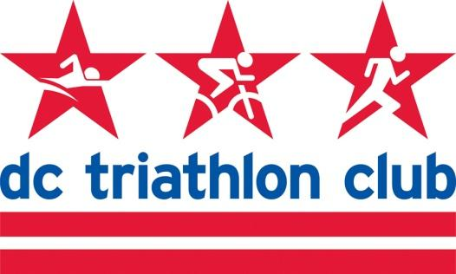

**JULY 2021 BOARD MEETING MINUTES**

Date: Monday, July 12, 2021

Location: Wundergarten DC

*In Attendance: Kyle, Liz, David, Cindy, Pat, Justin, Kelly, Rob, Stephan, Pat, Cynthia*

*Absent: Justin, Mallory*

**Review of May & June Meeting Minutes**

* May minutes were not approved at the June meeting due to the board meeting in person outdoors without wifi/connection.
* May approved
* June approved

**Financial Review, Budget Update (Pat)**

* Finances:
  + Fiscal picture as a whole is staying constant and even improving, even though we’ve had a few large expenses from various programs the past couple of months.
  + Much has been bolstered by a good uptick in membership over the last three months.
  + Still a little percentage down year-over-year, but compared to earlier this year it has been a marked improvement.
  + Gear income is continuing to come in - credit to Mallory for continuing to sell the old gear.
  + Finances are in a stronger position than this time last year. Sound overall situation right now, especially if there were unforeseen circumstances.

**Bank accounts/voting on fiduciary responsibility (Kyle/Patrick)**

* Need the board’s concurrence to open the new bank account at Capital One. Need to have a resolution that the board supports that can be notarized so Patrick can open the account and add new signers.
* Patrick screen shared a Resolution he drafted
* Discussion of the reason for a Cap One account vs. Bank of America - better savings interest rate than Bank of America.
* We had a Cap One account in the past but was closed in October 2019.
* We won’t close BoA yet, but make the transition in September/October.
* Motion approved to proceed unanimously

**2021 Programs (Cindy)**

* Masters Swim
  + Permit is in - she hopes
  + DC would not answer the questions so she documented them in the permit process
  + Permit window is open through end of this week, then it is 21 days.
  + New program manager hasn’t responded yet but we have some time, Kyle and Cindy will discuss. He was going to touch base with James to discuss the role.
  + It would start September 8
* Other programs
  + Will get together in August with program leads to discuss how to launch programs for next year
* OSP
  + Soon we will assess in person spaces and format
  + We had some requests to consider keeping a virtual option

**Annual Meeting (Kyle)**

* In person event this year. Considering locations - same location (Arlington Cinema and Drafthouse) or look for another?
* In the past we had coordinated around the Ironman Kona viewing, but the past two years they aired that on Thanksgiving weekend, so this timing didn’t work for us. We played the video without commercials.
* Not enough time to do all the raffles this way.
* Drafthouse is a great place for people to socialize
* Kona or DVDs of Triathlon at the Olympics and Kona highlights
  + Table the entertainment decisions
* Date - look at December 11 to stay with previous pattern
  + Discussion of moving it earlier into November - conflicts with running races that are popular with members (Richmond, Rehoboth, etc.)
* Cynthia and Kyle will discuss and hold the date with the Drafthouse

**Gear (Kyle)**

* Some people have received the gear orders, but everyone will get it in the next couple of weeks.
* Mallory reported to Liz that Cutaway was expecting to get by the 16th and then shipping shortly thereafter
* TriOut is interested in branded race belts and Mallory is looking into this

**Training Camp (Kelly)**

* 15 people are registered for camp
* A lot of engagement over email
* A few people have volunteered to help with things over the weekend
* Very excited it’s happening
* Do we need another social/marketing push or are we okay on registrations?
  + Yes it wouldn’t hurt since we are about to coordinate on logistics
  + We are two weeks out
  + We have 5 campsites reserved
  + 10 people are camping (some are in the same tent)
  + The sites accommodate 3 tents but 2 is fine
  + Some people are staying in an AirBnB
  + If Kelly needs supplies or other support contact Cynthia and others

**CalTri (Rob)**

* CalTri is presenting a race at General Smallwood on September 12
* Tri series is adding events and draws newer athletes
* They have a variety of events (triathlon, duathlon)
* They are open to having a camp as well
* Balancing the need for volunteers and other advance work we would need to do with other events happening at the same time
* We can put a call for volunteers in the newsletter for a water stop
* Other things on the list of options for the partnership were discussed. Some great options but we are hesitant to commit to specific volunteer numbers or financial commitments for the first race, and one of the first back since the pandemic.

**Wrap Up, Around the Room**

* Liz - July Club Happy Hour will be in Arlington. Working on August HH in Montgomery County.
* Rob - June happy hour had a great turnout
* Kyle will take the September HH planning in the city at an outdoor space
* No August meeting due to travel schedules - check ins and financials via email. Keep group informed of things.