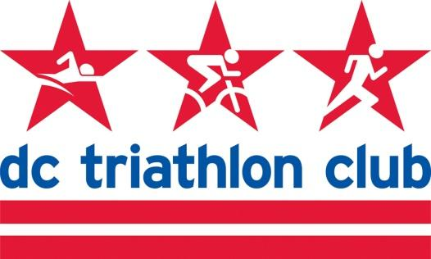

**JANUARY 2022 BOARD MEETING MINUTES**

Date: Monday, January 10, 2022

Location: Virtual

*In Attendance: Kyle, David, Liz, Pat, Kelly, Rob, Pat, Mallory, Cindy, Cynthia*

*Absent: N/A*

**Review of November Meeting Minutes**

* Approved

**Financial Review, Budget Update (Pat)**

* Year-End financials review from 2021
* Two Capital One accounts are up and running. No second checking account - one checking, one savings account
  + Former second BoA account and savings
  + Kept some money in the account in case of an unexpected charge and did have a recurring PayPal service change.
  + All is transitioned now to PayPal and Capital One.
  + Cynthia to look at the address book/contact list in BoA to see what information we need to transfer. Should ask all payees for current addresses now anyhow after a couple of years with the pandemic.
* We ended up very close to what we had projected
* Program revenue will be coming in
* Annual meeting gear sales came in and helped a chunk of the meeting expenses - great work on Mallory’s part.
* Overall income down
* Inversely last year - membership dues were biggest income driver when it is usually training programs. Will likely come back to usual now that programs are reopening.
* Operations expenses are our largest driver of cost right now.
* A lot to be optimistic about right now

**2022 Roles/Elections**

* Discussion of board member roles and if people would like to change roles
* Jorge was elected to the board and is moving but is willing to continue in a tech role
* Have someone else interested and we can take a vote at the next meeting
* For non-executive board, they will remain in their current positions
* Executive Committee - nominations were made for President (Kyle Simpson), Vice President (Rob Read), Secretary (Liz Glomb), Treasury (Patrick Pannett). The board voted unanimously to accept these positions for the 2022 year.

**Annual Meeting Recap**

* Went well and thanks to the board for help with the meeting

**Programs (Cindy)**

* OSP
  + Cynthia gave a report - 51 people attending including board members
* NTP
  + Information meeting was yesterday. 79 people were on the Zoom call including panelists and leadership team.
  + 66 people signed up - 20+ are deferrals from 2020
  + Discounted price goes through January 15
  + Next meeting is the end of February for the Kickoff, before clinic days in March
  + Bricnic date on the NTP schedule was TBD - do we have a date for this?
    - Kelly - had an initial conversation with Jeff Halper about the MoCo bricnic in April in Montgomery County.
    - Looking at other options

* ODP/HIP/IMP
  + Olympic has low enrollment compared to others at the moment
  + Still getting a lot of questions about which program people should enroll in
  + Stephan is very positive about making it work
  + Kickoff is next week - Wednesday, January 19 in the evening. Scheduled in person but will likely transition to Zoom.
  + Clinic Days - Catholic University Spring Break - March 6 & 13 seem to be locked in
* Masters
  + Applied for Wilson permits, should hear February 14 if they stick to that date
  + UDC - Cindy has emailed with them and they aren’t renting pool space yet. When they do we will get our morning time slots back.
  + Question for the board
    - We don’t have a Masters Swim coach/lead right now. Two years ago before the pandemic we were struggling to get on-deck coaching for the program.
    - The program is successful for the club but we were having staffing issues, and right now have pool issues.
    - Board should discuss if we are going to be able to resume our previous level of program of Masters Swim.

**Partnerships**

* We have been approached by a few entities for partnerships
* The Feed - sports nutrition. Discussion of potential partnership.
* Iron Realtor - discussion of potential partnerships.

**Tech**

* We have three email accounts that Patrick has identified we could get rid of that haven’t been accessed in a long time. (shipping@, ironmantriclub@, lgbtq@)
  + Cynthia - updating website will make sure the old emails aren’t listed
* Other accounts with vacant/consolidated board roles - events, etc. - could deactivate and reactivate in the future. Check for contracts or other historic info.
* Races on the website - Cynthia working on this. Emailed the board.
  + Featured races each month to drive club turnout and have the club tent
  + Members will know there will be a community there
  + Cynthia will add those to the website - Buzz
* Discount codes to be updated on the website
* Justin R is training Jorge in how to do the website and registrations
* Discussion of updating website pages and content to be more current
* Consolidating information - lots of info on it and some info found in multiple places
* Cynthia will dedicate hours for this

**2022 Member Meetings/HH**

* Discussion of a date for a spring member meeting outside
* Happy hours - inside due to cold, so perhaps halt these for Jan/Feb and bring them back in nicer weather.
* Zoom option - something with a partner - so that new members and others can get engaged with other club members

**Budget/Retreat Pre-Planning**

* Budget
  + If there are items for the budget to consider, send it to Kyle and Patrick
  + Refunds - we lose money. We say “no refunds” but do it on occasion for an injured athlete, etc.
* Board Retreat
  + In the past the board went away. Could have a day-long gathering or meeting in the city.
  + Helpful to talk strategy, longer-term vision.
  + Liz offered a farmhouse in Virginia for a retreat location