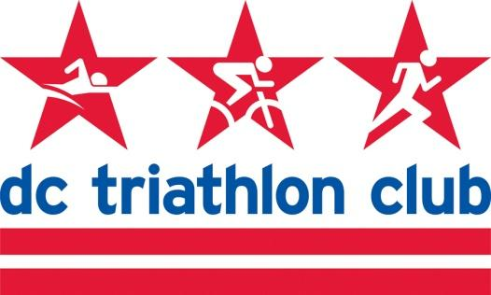

**FEBRUARY 2022 BOARD MEETING MINUTES**

Date: Monday, February 7, 2022

Location: Virtual

*In Attendance: Kyle, Liz, Pat, Kelly, Rob, Pat, Mallory, Cindy, Juene, Cynthia*

*Absent: David*

**Review of January Meeting Minutes**

* Approved

**Welcome Juene**

* Juene interested in joining the board, gave an introduction.
* Board voted to appoint her to the board.
* Partnerships role.

**Financial Review, Budget Update (Pat)**

* Solid results across programs and gear.
* Planning for budgets starting next month.
* Stable with the transition to the new Capital One accounts.

**Programs (Cindy)**

* Olympic and Half programs are a little low compared to usual.
* Typically use the forums or a separate group text. Using GroupMe this year and had three threads - combined all three groups together so they have a community feel and share information.
* Masters Swim
  + Pool access has been challenging with Covid.
  + We do not have a lead and when we did, we were struggling to get coaches on deck. It is “human-intensive”.
  + Pat - If we can’t get slots that are worthwhile and struggling with coaches, think about a platform we can bring in or develop coaching sets. A remote-curated program. Giving people the ability to meet and do the swim together.
  + Mallory - Could we send weekly workouts, and help connect people to do swim workouts together.
  + Take it off the website for now.

**Retreat**

* Dates are challenging - Kyle will do a survey/poll for dates.

**Happy Hours**

* In person happy hours can resume. Used to be 3rd Thursday of the month.
* PRR is willing to host a Fit Kit try-on and then we can have a happy hour nearby
  + Can do this February 24 to coordinate with NTP launch
* March 17 or 24 - David can coordinate

**Future Board Meetings**

* Would like to try and meet in person next month
* Kyle can host again - if we are okay to be inside if it is cold, otherwise outside at the firepits
* Pi day - we will get pizza and someone will bring pie :)